***Hippity’s Hop***

***Game Design Document (GDD)***

***‘LET’S HOPPITY!!’*** – Hippity (Kyle O’Dell)

This page: Table of Contents and Team Member Listing

|  |  |  |
| --- | --- | --- |
| Table of Contents  [1 Game Overview](https://n-xovwktmtjsnaxyc2mwes2xu7pohqedmdm6zjw5q-2lu-script.googleusercontent.com/userCodeAppPanel)  [2 High Concept](https://n-xovwktmtjsnaxyc2mwes2xu7pohqedmdm6zjw5q-2lu-script.googleusercontent.com/userCodeAppPanel)  [3 Unique Selling Points](https://n-xovwktmtjsnaxyc2mwes2xu7pohqedmdm6zjw5q-2lu-script.googleusercontent.com/userCodeAppPanel)  [4 Platform Minimum Requirements](https://n-xovwktmtjsnaxyc2mwes2xu7pohqedmdm6zjw5q-2lu-script.googleusercontent.com/userCodeAppPanel)  [5 Competitors / Similar Titles](https://n-xovwktmtjsnaxyc2mwes2xu7pohqedmdm6zjw5q-2lu-script.googleusercontent.com/userCodeAppPanel)  [6 Synopsis](https://n-xovwktmtjsnaxyc2mwes2xu7pohqedmdm6zjw5q-2lu-script.googleusercontent.com/userCodeAppPanel)  [7 Game Objectives](https://n-xovwktmtjsnaxyc2mwes2xu7pohqedmdm6zjw5q-2lu-script.googleusercontent.com/userCodeAppPanel)  [8 Game Rules](https://n-xovwktmtjsnaxyc2mwes2xu7pohqedmdm6zjw5q-2lu-script.googleusercontent.com/userCodeAppPanel)  [9 Game Structure](https://n-xovwktmtjsnaxyc2mwes2xu7pohqedmdm6zjw5q-2lu-script.googleusercontent.com/userCodeAppPanel)  [10 Game Play](https://n-xovwktmtjsnaxyc2mwes2xu7pohqedmdm6zjw5q-2lu-script.googleusercontent.com/userCodeAppPanel)  [10.1 Game Controls](https://n-xovwktmtjsnaxyc2mwes2xu7pohqedmdm6zjw5q-2lu-script.googleusercontent.com/userCodeAppPanel)  [10.2 Game Camera](https://n-xovwktmtjsnaxyc2mwes2xu7pohqedmdm6zjw5q-2lu-script.googleusercontent.com/userCodeAppPanel)  [10.2.1 HUD](https://n-xovwktmtjsnaxyc2mwes2xu7pohqedmdm6zjw5q-2lu-script.googleusercontent.com/userCodeAppPanel)  [10.2.2 Maps](https://n-xovwktmtjsnaxyc2mwes2xu7pohqedmdm6zjw5q-2lu-script.googleusercontent.com/userCodeAppPanel)  [11 Players](https://n-xovwktmtjsnaxyc2mwes2xu7pohqedmdm6zjw5q-2lu-script.googleusercontent.com/userCodeAppPanel)  [11.1 Characters](https://n-xovwktmtjsnaxyc2mwes2xu7pohqedmdm6zjw5q-2lu-script.googleusercontent.com/userCodeAppPanel)  [11.2 Metrics](https://n-xovwktmtjsnaxyc2mwes2xu7pohqedmdm6zjw5q-2lu-script.googleusercontent.com/userCodeAppPanel)  [11.3 States](https://n-xovwktmtjsnaxyc2mwes2xu7pohqedmdm6zjw5q-2lu-script.googleusercontent.com/userCodeAppPanel)  [11.4 Weapons](https://n-xovwktmtjsnaxyc2mwes2xu7pohqedmdm6zjw5q-2lu-script.googleusercontent.com/userCodeAppPanel)  [12 Player Line-up](https://n-xovwktmtjsnaxyc2mwes2xu7pohqedmdm6zjw5q-2lu-script.googleusercontent.com/userCodeAppPanel)  [13 NPC](https://n-xovwktmtjsnaxyc2mwes2xu7pohqedmdm6zjw5q-2lu-script.googleusercontent.com/userCodeAppPanel)  [13.1 Enemies](https://n-xovwktmtjsnaxyc2mwes2xu7pohqedmdm6zjw5q-2lu-script.googleusercontent.com/userCodeAppPanel)  [13.1.1 Enemy States](https://n-xovwktmtjsnaxyc2mwes2xu7pohqedmdm6zjw5q-2lu-script.googleusercontent.com/userCodeAppPanel)  [13.1.2 Enemy Spawn Points](https://n-xovwktmtjsnaxyc2mwes2xu7pohqedmdm6zjw5q-2lu-script.googleusercontent.com/userCodeAppPanel)  [13.2 Allies / Companions](https://n-xovwktmtjsnaxyc2mwes2xu7pohqedmdm6zjw5q-2lu-script.googleusercontent.com/userCodeAppPanel)  [13.2.1 Ally States](https://n-xovwktmtjsnaxyc2mwes2xu7pohqedmdm6zjw5q-2lu-script.googleusercontent.com/userCodeAppPanel)  [13.2.2 Ally Spawn Points](https://n-xovwktmtjsnaxyc2mwes2xu7pohqedmdm6zjw5q-2lu-script.googleusercontent.com/userCodeAppPanel)  [14 Art](https://n-xovwktmtjsnaxyc2mwes2xu7pohqedmdm6zjw5q-2lu-script.googleusercontent.com/userCodeAppPanel)  [14.1 Setting](https://n-xovwktmtjsnaxyc2mwes2xu7pohqedmdm6zjw5q-2lu-script.googleusercontent.com/userCodeAppPanel)  [14.2 Level Design](https://n-xovwktmtjsnaxyc2mwes2xu7pohqedmdm6zjw5q-2lu-script.googleusercontent.com/userCodeAppPanel)  [14.3 Audio](https://n-xovwktmtjsnaxyc2mwes2xu7pohqedmdm6zjw5q-2lu-script.googleusercontent.com/userCodeAppPanel)  [15 Procedurally Generated Content](https://n-xovwktmtjsnaxyc2mwes2xu7pohqedmdm6zjw5q-2lu-script.googleusercontent.com/userCodeAppPanel)  [15.1 Environment](https://n-xovwktmtjsnaxyc2mwes2xu7pohqedmdm6zjw5q-2lu-script.googleusercontent.com/userCodeAppPanel)  [15.2 Levels](https://n-xovwktmtjsnaxyc2mwes2xu7pohqedmdm6zjw5q-2lu-script.googleusercontent.com/userCodeAppPanel)  [15.3 Artificial Intelligence NPC](https://n-xovwktmtjsnaxyc2mwes2xu7pohqedmdm6zjw5q-2lu-script.googleusercontent.com/userCodeAppPanel)  [15.4 Visual Arts](https://n-xovwktmtjsnaxyc2mwes2xu7pohqedmdm6zjw5q-2lu-script.googleusercontent.com/userCodeAppPanel)  [15.5 Audio](https://n-xovwktmtjsnaxyc2mwes2xu7pohqedmdm6zjw5q-2lu-script.googleusercontent.com/userCodeAppPanel)  [15.6 Minimum Viable Product (MPV)](https://n-xovwktmtjsnaxyc2mwes2xu7pohqedmdm6zjw5q-2lu-script.googleusercontent.com/userCodeAppPanel)  [16 Wish List](https://n-xovwktmtjsnaxyc2mwes2xu7pohqedmdm6zjw5q-2lu-script.googleusercontent.com/userCodeAppPanel)   |  | | --- | |  | | Game Development Team Members    PRODUCER  Kyle O’Dell    PRODUCTION MANAGER  Kyle O’Dell    PRODUCTION COORDINATOR  Kyle O’Dell  GAME DESIGNERS  Kyle O’Dell  SYSTEMS/IT COORDINATOR  Kyle O’Dell  PROGRAMMERS  Kyle O’Dell  TECHNICAL ARTISTS  Kyle O’Dell  AUDIO ENGINEERS  Kyle O’Dell  UX TESTERS  Kyle O’Dell |

|  |
| --- |
|  |

# 1 Game Overview

Title: Hippity’s Hop

Platform: PC Standalone

Genre: 3D Platformer / Adventure

Rating: (10+) ESRB

Target: Casual gamer (aging from 12 - 30)

Release date: May, 2020

Publisher: MSO Productions

Hippity’s Hop is a 3D platformer and adventure game where the Player has to help Hippity find his grandfathers lost orbs, requiring the player to overcome obstacles, survive enemies, and solve puzzles.

# 2 High Concept

Hippity’s Hop places the player initially in an expansive terrain where the player can explore to discover lost orbs. Along the terrain are small fast enemies who will attack the player, and the player must evade their attacks due to the lack of weapons.

# 3 Unique Selling Points

* Unique story
* Multiplatform across Windows/Linux/Mac OS

# 4 Platform Minimum Requirements

PC, MAC AND LINUX STANDALONE

Build for modern PC.

# 5 Competitors / Similar Titles

//TODO:

# 6 Synopsis

Landing in an unknown terrain, it’s up to you to explore and find out what is happening. Upon entering a house nearby, you meet Hippity, and unusual but happy, nice character who is asking you a favor to find his grandfathers lost orbs. He says they mean a lot to him. Go on an adventure to find his lost orbs, but also discover the truth about Hippity.

# 7 Game Objectives

Proceed through the various maps, surviving the attacks of Mini-Enemies, and try to find all of the orbs, puzzles, and fights.

# 8 Game Rules

Player has no means of fighting, must evade attacks and even sometimes use the environment to fight. Player must find certain number of orbs to proceed through certain areas and levels.

# 9 Game Structure

Main Menu 🡪 FirstLevel 🡪 Find Ten Orbs 🡪 SecondLevel 🡪 Complete Puzzle 🡪 FinalLevel 🡪 Beat Boss 🡪 Credits

If HP = 0 🡪 Gameover screen

# 10 Game Play

## 10.1 Game Controls

WASD – Move player

Space -- Jump

Shift(Hold while moving) -- Sprint

E – Speak, read, interact with objects

## 10.2 Game Camera

Camera focuses on players first person perspective.

### 10.2.1 HUD

//TODO

Player HP -- Informs player of remaining health

Inventory – Displays players items

Items – Items player can use

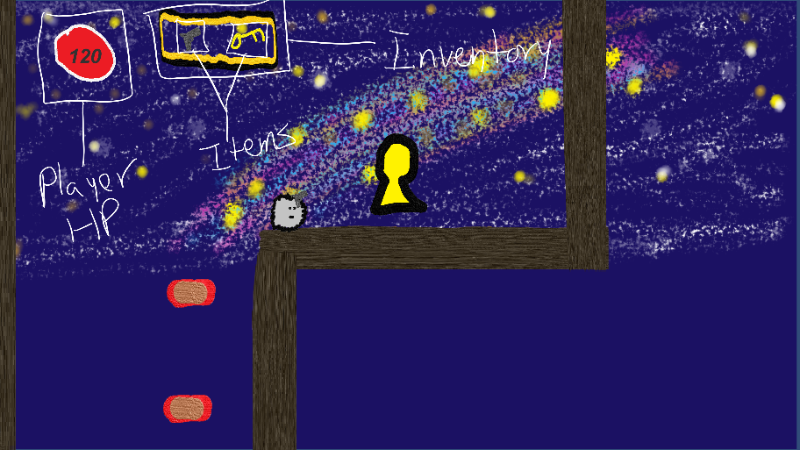

### 10.2.2 Maps

First Level

Second Level

Third Level

# 11 Players

## 11.1 Characters

//TODO

Ye Little Shammer – Our main protagonist is on his way home, but will have to fight his way through mobs of Red-Rah’s and seek through mysterious environments.

## 11.2 Metrics

Player Metrics:

Speed: 10

Max Health: 150

Attack Damage: 13

Time to attack: .5 seconds

## 11.3 States

Idle / Movement: Outer layer rotates

Death: Turns read with X eyes.

## 11.4 Weapons

Gun – Fires projectiles at a fully automatic rate, damaging enemies at 13 hp at a time.

# 12 Player Line-up

Captain Cah

Red-Rah

Exploding Red-Rah

Purple-Pah (Red-Rah leader)

# 13 NPC

## 13.1 Enemies

Red-Rah (Melee)

* HP = 250
* Speed = 7
* Jump = 250
* Damage = 5
* Cool down = .5 seconds

Red-Rah (Exploding)

* HP = 80
* Speed = 6
* Jump = 250
* Damage = 30
* Cool down = none, hits only once.

Purple-Pah (Boss)

* HP = 2000
* Speed = 5
* Jump = 384
* Damage = 7
* Cool down = .3 seconds

### 13.1.1 Enemy States

Enemies behave in the same manner amongst the following states:

Alive: Enemy appears rotating, and will move towards player when in range.

Death: Enemy dies when hp reaches zero or less.

### 13.1.2 Enemy Spawn Points

All enemy types can spawn from the same spawner, the developer selects the desired enemy to be spawned from a particular spawner, and determines how many can spawn, and how soon.

## 13.2 Allies / Companions

### 13.2.1 Ally States

Animated – Captain Cah appears as a rotating body.

### 13.2.2 Ally Spawn Points

Captain Cah appears in checkpoints, and in various spots of each map.

# 14 Art

## 14.1 Setting

The game takes place in a fictional imaginary environment, houses are checkpoints.

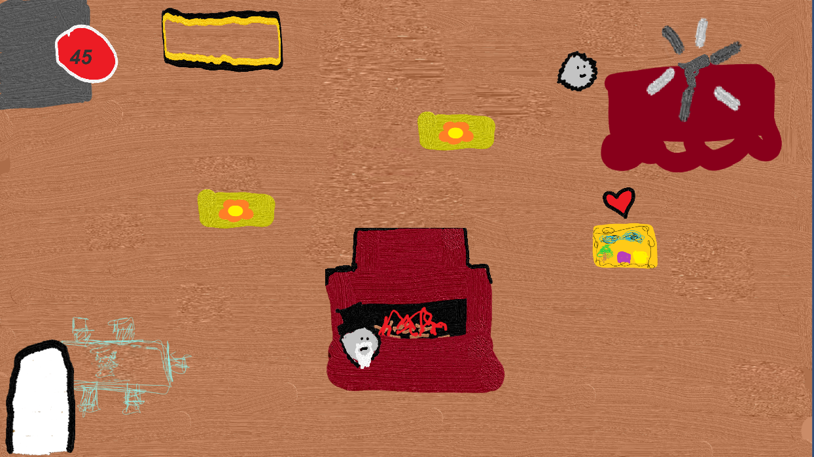

## 14.2 Level Design

Each level consists of platforms and enemies. Both will serve as challenges for the player, as the player progresses, the player may find houses which act as checkpoints when the player enters them. Some levels may have puzzles that unlock key items.

## 14.3 Audio

Credits – Music – Plays during gameover and credits

Introtrack-1 – Music – Plays in background of main menu

FULL2 – Music – Plays in background of second and third level

TestAudio – Music – Plays in background of first level

FULL2-1 – FX – Plays when player is on ship, or in checkpoints

EnemyDying – FX – Plays when an enemy dies

errorSound – FX – Plays when puzzle is done incorrectly

Explosion – FX – Plays when exploding red-rah explodes

greenLightSound – FX – Plays when green lights turn on

HealingSound – FX – Plays when Heart object is acquired

Hit-sound – FX – Plays when player gets hit

Jumping – FX – Plays when player jumps

Pew – FX – Plays when player shoots gun

Player-dying – FX – Plays when player dies

# 15 Procedurally Generated Content

**N/A**

## 15.1 Environment

N/A

## 15.2 Levels

N/A

## 15.3 Artificial Intelligence NPC

N/A

## 15.4 Visual Arts

N/A

## 15.5 Audio

N/A

## 15.6 Minimum Viable Product (MPV)

* Built for the PC platform

# 16 Wish List

* More NPCs
* More levels
* Larger story
* Character development
* More items
* More weapons
* More abilities
* Skills

**Bibliography**

Kyle O’Dell

Department of Computer Science, San Diego State University

CS 583: 3D Game Programming

Professor Price

April 9, 2020

**References**

Thirslund, A. [Brackeys]. (2018, July 15). 2D Movement in Unity (Tutorial)[Video file]. Retrieved

from https://www.youtube.com/watch?v=dwcT-Dch0bA&t=220s

Thirslund, A. [Brackeys]. (2018, September 16). 2D Shooting in Unity (Tutorial)[Video file].

Retrieved from https://www.youtube.com/watch?v=wkKsl1Mfp5M

Thirslund, A. [Brackeys]. (2017, July 23). How to make a Dialogue System in Unity [Video file].

Retrieved from https://www.youtube.com/watch?v=_nRzoTzeyxU&t=593s

Thirslund, A. [Brackeys]. (2017, December 20). PAUSE MENU in Unity [Video file]. Retrieved

from https://www.youtube.com/watch?v=JivuXdrIHK0&t=458s

Thirslund, A. [Brackeys]. (2020, February 9). How to make a HEALTH BAR in Unity! [Video file].

Retrieved from https://www.youtube.com/watch?v=BLfNP4Sc_iA

**Original Assets**

Soundtrack:

Main Menu Theme – Written and produced by Kyle O’Dell

Gameover / credits theme – Written and produced by Kyle O’Dell

First level theme – Written and produced by Kyle O’Dell

Second level theme – Written and produced by Kyle O’Dell

Final level theme – Written and produced by Kyle O’Dell

Sounds:

Player death sounds – recorded by Kyle O’Dell

Player hit sounds – recorded by Kyle O’Dell

Enemy death sounds – recorded by Kyle O’Dell

Captain Cah’s voice – Kyle O’Dell

Jumping Sound – recorded by Kyle O’Dell

Green Light Activation sound – recorded by Kyle O’Dell

Running water sound – recorded by Kyle O’Dell

Gun shooting sound – recorded by Kyle O’Dell

Gaining health sound – recorded by Kyle O’Dell

Artwork:

Little Shammer character – Kyle O’Dell

Captain Cah character – Kyle O’Dell

Melee enemy – Kyle O’Dell

Exploding Enemy – Kyle O’Dell

Boss enemy – Kyle O’Dell

Hearts – Kyle O’Dell

Main Menu background – Kyle O’Dell

Tutorial level background – Kyle O’Dell

Ship Scene background – Kyle O’Dell

First level background – Kyle O’Dell

Second level background – Kyle O’Dell

Final level background – Kyle O’Dell

Red platforms – Kyle O’Dell

Flower platforms – Kyle O’Dell

Yellow platforms – Kyle O’Dell

Ship Platforms – Kyle O’Dell

Ground – Kyle O’Dell

House – Kyle O’Dell

Fireplace – Kyle O’Dell

Gun – Kyle O’Dell

Key – Kyle O’Dell

Keyhole – Kyle O’Dell

HUD inventory – Kyle O’Dell

Projectiles – Kyle O’Dell

**Play Testers**

Kyle McLain Kane

Maria Jose Molina Sanchez O’Dell

Michael Scott

Nathan Lehenbauer

Nhat Ho

Tim Backus

Jamshid Aziz

Norman Chau

Christopher Bradford

Michael Ruiz

Ivan Delgado